**Execution steps of PANDA**

# (Project of artificial intelligence for Deaf and Aphonic)

1. Import the required python libraries
2. Download the CUDA and set up that in your system.
3. Open the folder in VSCODE
4. Set the file address correctly (linking files for the execution like Model.h5)

5.after all the setting run the main.py file

6.It Execute and open a user interface of the PANDA.

**OUTPUT**

1. This is the interface you will get after running the main.py file.

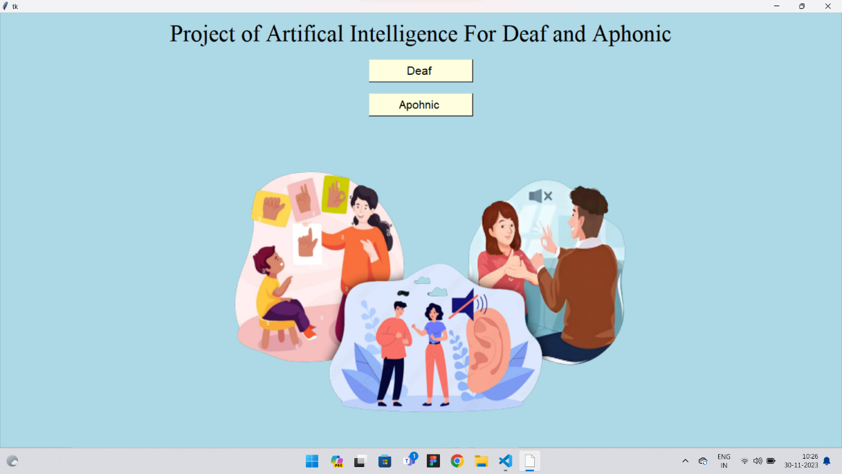

1. 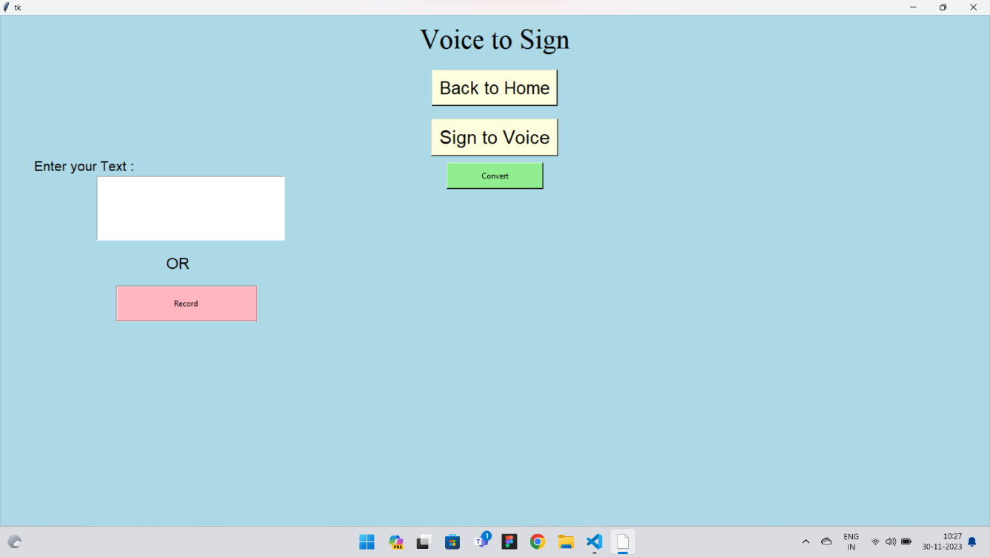this will be the interface you will get if you click the deaf option.
2. This will be the interface you will get If you click the Aphonic option.

